Code Practise

Jessica Gurung
Westcliff University , Kings College
PRG 200
Professor Ashok
May 17, 2026

Python Variables
Variables are containers for storing data values. Python has no command for declaring a variable.
A variable is created the moment you first assign a value to it.
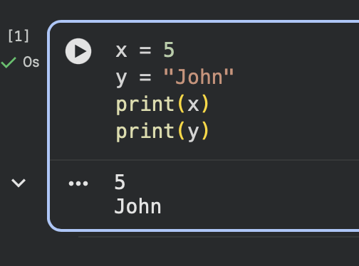
Variables do not need to be declared with any particular type, and can even change type after they have been set. :
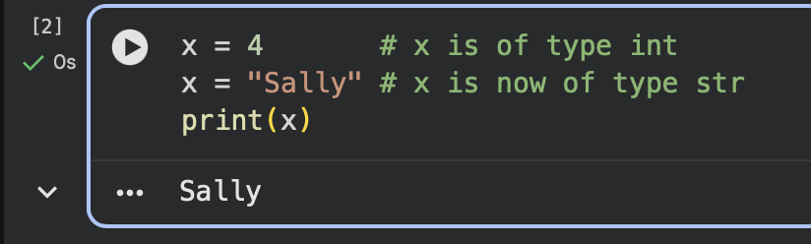

If you want to specify the data type of a variable, this can be done with casting. :
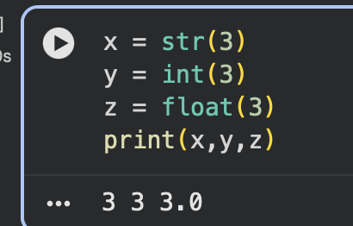

Variable Names
A variable can have a short name (like x and y) or a more descriptive name (age, carname, total_volume).
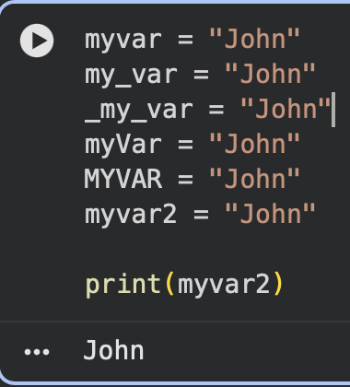

Assign Multiple Values

Python allows you to assign values to multiple variables in one line:

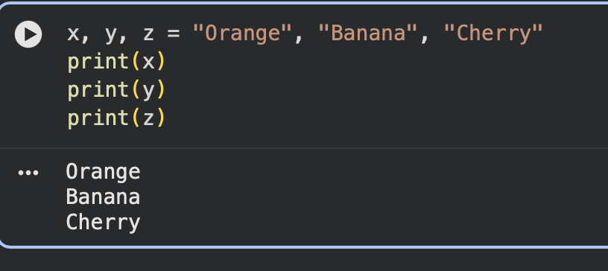
And you can assign the same value to multiple variables in one line:
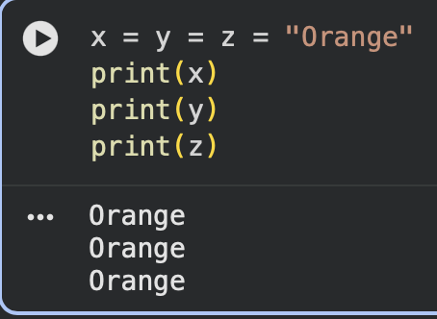
If you have a collection of values in a list ,tulip, etc. Python allows you to extract the values into variables. This is called unpacking. :
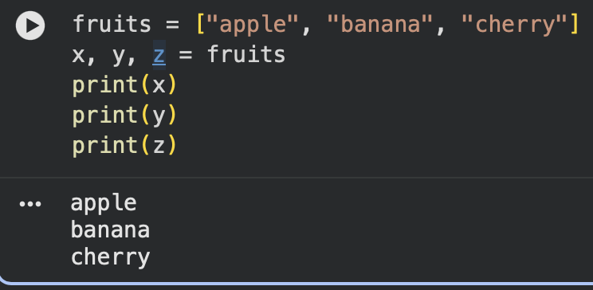

Output Variables
The print() function is often used to output variables.
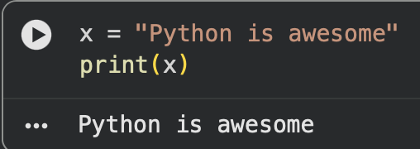
In the print() function, you output multiple variables, separated by a comma :
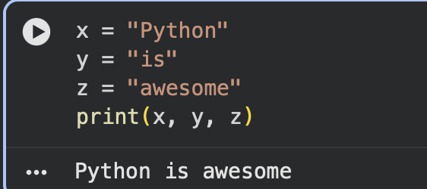
You can also use the + operator to output multiple variables :
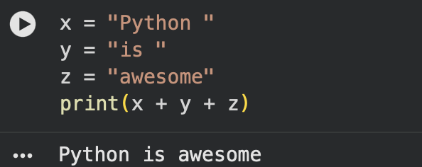
For numbers, the + character works as a mathematical operator :
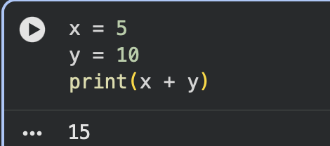
The best way to output multiple variables in the print() function is to separate them with commas, which even support different data types :
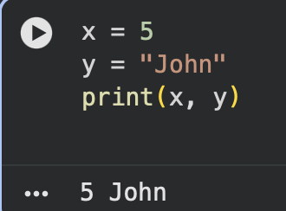

Global Variables
Variables that are created outside of a function (as in all of the examples in the previous pages) are known as global variables. It can be used both inside of functions and outside.
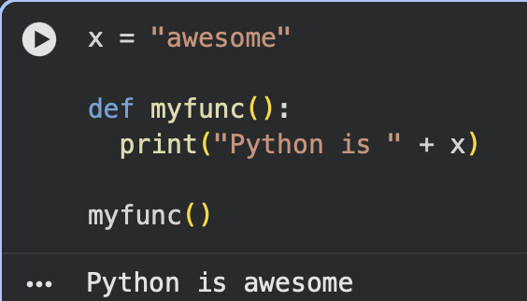
Creating a variable with the same name inside a function, this variable will be local, and can only be used inside the function. The global variable with the same name will remain as it was, global and with the original value.
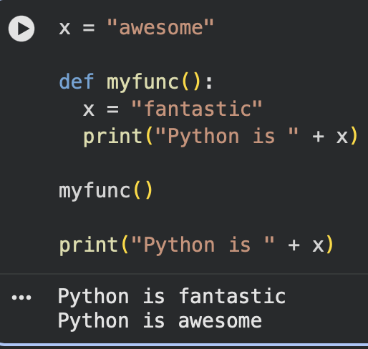
Normally, when you create a variable inside a function, that variable is local, and can only be used inside that function.
To create a global variable inside a function, you can use the global keyword.
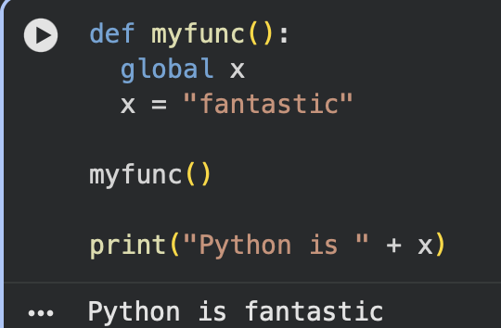
Also, use the global keyword if you want to change a global variable inside a function.
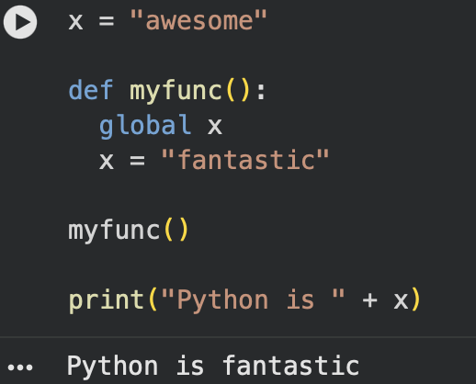

Python Data Types
In programming, data type is an important concept. Variables can store data of different types, and different types can do different things.
You can get the data type of any object by using the type() function:
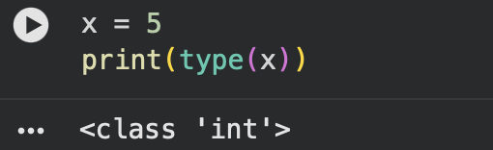

Python Numbers :
There are three numeric types in Python: int, float , complex
Variables of numeric types are created when you assign a value to them :
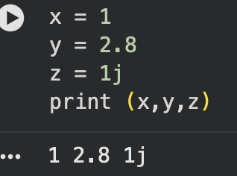
To verify the type of any object in Python, use the type() function :
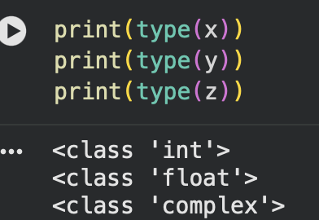
Int, or integer, is a whole number, positive or negative, without decimals, of unlimited length :
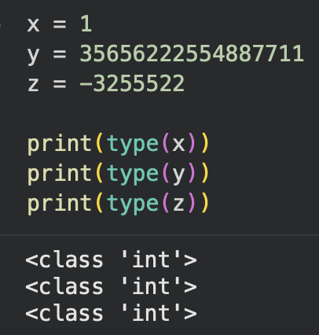

Float, or "floating point number" is a number, positive or negative, containing one or more decimals. :
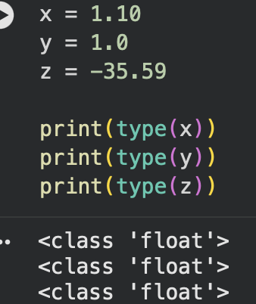
Float can also be scientific numbers with an "e" to indicate the power of 10 :
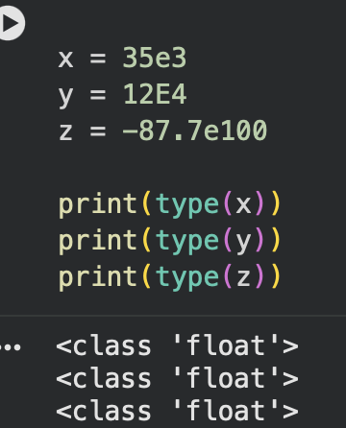

Try It Yourself Section :
Creating Variables :
This creates two variables. x stores a number (integer) and y stores text (string). print() displays the values on the screen.
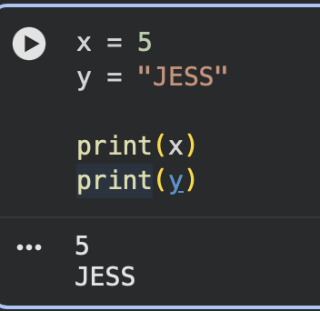
Changing Variable Type :
The variable x first stores a number, then changes to text. Python allows variables to change data types easily because it is dynamically typed.
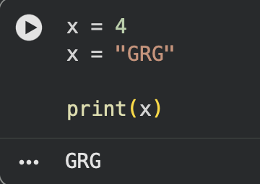
Casting Variable :
Casting changes a value into another data type. str() converts to string, int() converts to integer, and float() converts to decimal number.

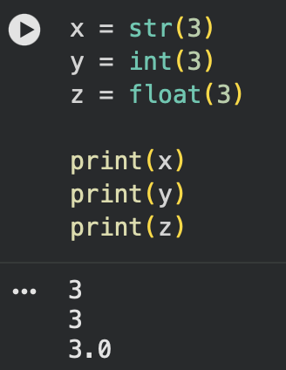
Variable Nmae :
This shows valid variable naming styles in Python such as camelCase, snake_case, and PascalCase. Good variable names make code easier to read.
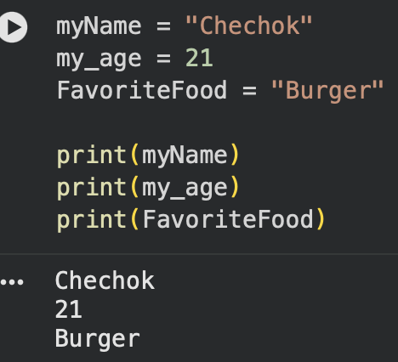
Assign Multiple Value :
Python can assign multiple values to multiple variables in a single line, making the code shorter and more efficient.

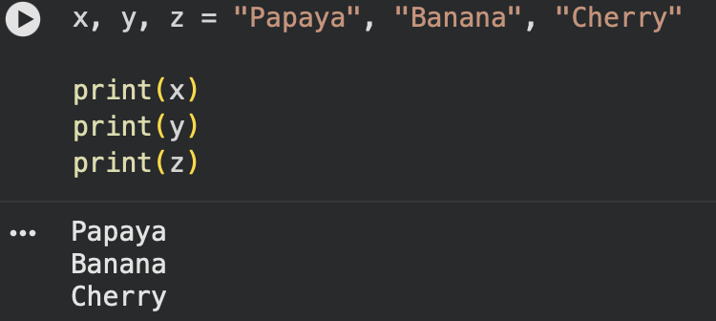
Output Variable :
Multiple variables can be printed together using commas inside print(). Python automatically adds spaces between them.
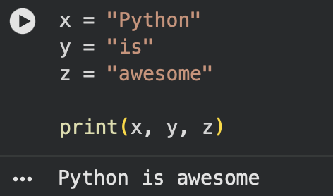
Global Variable :
A global variable is created outside a function and can be used anywhere in the program, including inside functions.
